Operating systems FAQ
The following questions cover first 4 units of paper III new syllabus
Unit I
Chapter1
- State any three essential properties of the following OS:
(1) Time sharing (ii) network OS
Time-Sharing Systems–Interactive Computing
- The CPU is multiplexed among several jobs that are kept in memory and on disk (the CPU is allocated to a job only if the job is in memory).
- A job swapped in and out of memory to the disk.
- On-line communication between the user and the system is provided; when the operating system finishes the execution of one command, it seeks the next “control statement” from the user’s keyboard.
- On-line system must be available for users to access data and code.
Distributed Systems
- Distribute the computation among several physical processors.
- Loosely coupled system – each processor has its own local memory; processors communicate with one another through various communications lines, such as high-speed buses or telephone lines.
- Advantages of distributed systems.
- Resources Sharing
- Computation speed up – load sharing
- Reliability
- Communications
- Requires networking infrastructure.
- Local area networks (LAN) or Wide area networks (WAN)
- May be either client-server or peer-to-peer systems.

- describe the working of one of the following working environment
(1) client server (2)peer to peer

Client-Server Systems
As PCs have become faster, more powerful, and cheaper, designers have shifted away from the centralized system architecture. Terminals connected to centralized systems are now being supplanted by PCs. Correspondingly; user-interface functionality that used to be handled directly by the centralized systems is increasingly being handled by the PCs As a result centralized systems today act as server systems to satisfy requests generated by client systems. The general structure of a client—server system is depicted in below.
Server systems can be broadly categorized as compute servers and file servers.
Compute-server systems provide art interface to which clients can send requests to perform an action, in response to which they execute the action and send back results to the client.

File-server systems provide a file-system interface where clients can create, update, read, and delete files.

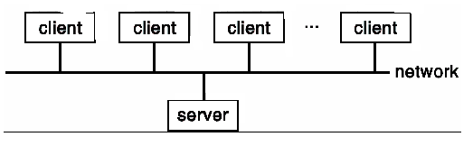

Peer-to-Peer Systems
The growth of computer networks—especially the Internet and World Wide Web (WWW) has had a profound influence on the recent development of operating systems. When PCs were introduced in the 1970s, they were designed
For personal use and were generally considered standalone computers. With the beginning o( widespread public use of the internet in the 1980s for electronic mail, ftp, and gopher, many PCs became connected to computer networks. With the introduction of the Web in the mid-1990s, network connectivity became an essential component of a computer system.
Virtually all modern PCS and workstations are capable of running a web browser for accessing hypertext documents on the Web. Operating systems (such as Windows, OS/2, Macos, and UNIX) now also include the system software (such as TCP/IP and PPP) that enables a computer to access the Internet via a local-area network or telephone connection. Several include the web browser itself, as well as electronic mail, remote login, and file-transfer clients and servers.
In contrast to the tightly coupled systems the computer networks used in these applications consist of a collection of processors that do not share memory or a clock. Instead, each processor has its own local memory. The processors communicate with one another through various communication lines, such as high-speed buses or telephone lines. These systems are usually referred to as loosely coupled systems (or distributed systems).
Some operating systems have taken the concept of networks and distributed systems further than the notion of providing network connectivity. A network operating system is an operating system that provides features such as file sharing across the network, and that includes a communication scheme that allows different processes on different computers to exchange messages. A computer running a network operating system acts autonomously from all other computers on the network, although it is aware of the network and is able to communicate with other networked computers. A distributed operating system is a less autonomous environment: The different operating systems communicate closely enough to provide the illusion that only a single operating system controls the network.

- explain the terms spooling, time sharing

Spooling
Time-sharing operating systems are even more complex than multi programmed operating systems. In both, several jobs must be kept simultaneously in memory, so the system must have memory management and protection To obtain a reasonable response time jobs may have to be swapped in and out of main memory to the disk that now serves as a backing store for main memory. A common method for achieving this goal is virtual memory, which is a technique that allows the execution of a job that may not be completely in memory. Swapping a job to main memory is called spooling

Time sharing
See question 1

chapter 3
- write a short note on any one
(1) Command interpreter (2) types of system calls
Command-Interpreter System
- Many commands are given to the operating system by control statements which deal with:
- process creation and management
- I/O handling
- secondary-storage management
- main-memory management
- file-system access
- protection
- networking
- The program that reads and interprets control statements is called variously:
- command-line interpreter
- shell (in UNIX)
Its function is to get and execute the next command statement.
System Calls
- System calls provide the interface between a running program and the operating system.
- Generally available as assembly-language instructions.
- Languages defined to replace assembly language for systems programming allow system calls to be made directly (e.g., C, C++)
- Three general methods are used to pass parameters between a running program and the operating system.
- Pass parameters in registers.
- Store the parameters in a table in memory, and the table address is passed as a parameter in a register.
- Push (store) the parameters onto the stack by the program, and pop off the stack by operating system.
Types of System Calls
- Process control
- File management
- Device management
- Information maintenance
- Communications

- Outline various operating system components in short.
Common System Components
- Process Management
- Main Memory Management
- File Management
- I/O System Management
- Secondary Management
- Networking
- Protection System
- Command-Interpreter System

- write short note on one of the following
1. categories of system programming 2.Layered approach to os structure
Categories of operating system
- Mainframe Systems
- Desktop Systems
- Multiprocessor Systems
- Distributed Systems
- Clustered System
- Real -Time Systems
- Handheld Systems

Layered Approach
- The operating system is divided into a number of layers (levels), each built on top of lower layers. The bottom layer (layer 0), is the hardware; the highest (layer N) is the user interface.
- With modularity, layers are selected such that each uses functions (operations) and services of only lower-level layers.
An Operating System Layer
OS/2 Layer Structure
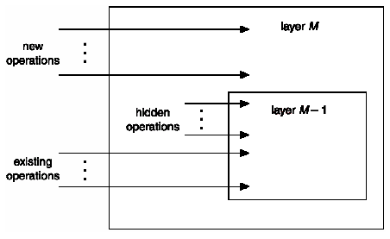

chapter 4

- Draw a neat diagram of vie state process model and explain the same
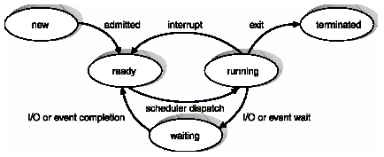
Process State
- As a process executes, it changes state
- new: The process is being created.
- running: Instructions are being executed.
- waiting: The process is waiting for some event to occur.
- ready: The process is waiting to be assigned to a process.
- terminated: The process has finished execution.

- Explain the purpose and structure of process control block in detail
Process Control Block (PCB)
Information associated with each process.
- Process state
- Program counter
- CPU registers
- CPU scheduling information
- Memory-management information
- Accounting information
- I/O status information
- Process state: The state may be new, ready, running, wailing, halted, and so on.
- Program counter: The counter indicates the address of the next instruction to be executed for this process.
- CPU registers: The registers vary in number and type, depending on the computer architecture. They include accumulators, index registers, stack pointers, and general-purpose registers, plus any condition-code information. Along with the program counter, this state information must be saved when an interrupt occurs, to allow the process to be continued correctly afterward
- CPU-scheduling in formation: This information includes a process priority, pointers to scheduling queues, and any other scheduling parameters.
- Memory-management information: This information may include such information as the value of the base and limit registers, the page tables, or the segment tables, depending on the memory system used by the operating system
- Accounting information: This information includes the amount of CPU and real time used, time limits, account numbers, job or process numbers, and so on.
- i/o status information: The information includes the list of i/o devices allocated to this process, a list of open files, and so on.
The PCB simply serves as the repository for any information that may vary from process to process.
- describe a tree of process in a typical OS. State the various reasons when a particular process is created and terminated.
Processes Tree on a UNIX System
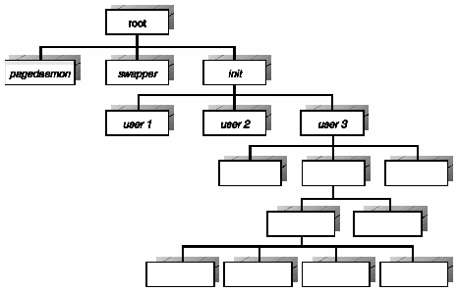
The processes in the system can execute concurrently and they must be created and deleted dynamically. Thus, the operating system must provide a mechanism (or facility) for process creation and termination.
Process Creation
- Parent process creates children processes, which, in turn create other processes, forming a tree of processes.
- Resource sharing
- Parent and children share all resources.
- Children share subset of parent’s resources.
- Parent and child share no resources.
- Execution
- Parent and children execute concurrently.
- Parent waits until children terminate.
- Address space
- Child duplicate of parent.
Child has a program loaded into it.
Process Termination
- Process executes last statement and asks the operating system to decide it (exit).
- Output data from child to parent (via wait).
- Process’ resources are deallocated by operating system.
- Parent may terminate execution of children processes (abort).
- Child has exceeded allocated resources.
- Task assigned to child is no longer required.
- Parent is exiting.
- Operating system does not allow child to continue if its parent terminates.
- Cascading termination.

- What are the different ways in which processes communicate with each other? Explain these in short.

Direct Communication
- Processes must name each other explicitly:
- send (P, message) – send a message to process P
- receive(Q, message) – receive a message from process Q
- Properties of communication link
- Links are established automatically.
- A link is associated with exactly one pair of communicating processes.
- Between each pair there exists exactly one link.
- The link may be unidirectional, but is usually bi-directional.
Indirect Communication
- Messages are directed and received from mailboxes (also referred to as ports).
- Each mailbox has a unique id.
- Processes can communicate only if they share a mailbox.
- Properties of communication link
- Link established only if processes share a common mailbox
- A link may be associated with many processes.
- Each pair of processes may share several communication links.
- Link may be unidirectional or bi-directional.
- Operations
- create a new mailbox
- send and receive messages through mailbox
- destroy a mailbox
- Primitives are defined as:
send(A, message) – send a message to mailbox A
receive(A, message) – receive a message from mailbox A
- Mailbox sharing
- P1, P2, and P3 share mailbox A.
- P1, sends; P2 and P3 receive.
- Who gets the message?
- Solutions
- Allow a link to be associated with at most two processes.
- Allow only one process at a time to execute a receive operation.
- Allow the system to select arbitrarily the receiver. Sender is notified who the receiver was.
Synchronization
- Message passing may be either blocking or non-blocking.
- Blocking is considered synchronous
- Non-blocking is considered asynchronous
- send and receive primitives may be either blocking or non-blocking.
- Blocking send: The sending process is blocked until the message is received by the receiving process or by the mailbox.
- Non-blocking send: The sending process sends the message and resumes operation.
- Blocking receive: The receiver blocks until a message is available
- Non-blocking receive: The receiver retrieves either a valid message or a null.
Different combinations of send and receive are possible. When both the send and receive are blocking, we have a rendezvous between the sender and the receiver.
Buffering
- Queue of messages attached to the link; implemented in one of three ways.
- Zero capacity – 0 messages
Sender must wait for receiver (rendezvous).
- Bounded capacity – finite length of n messages
Sender must wait if link full.
- Unbounded capacity – infinite length
Sender never waits.

Chapter 5
- Define a thread. Explain the three common ways of establishing a relation between User level and kernel level threads (2R).

Threads
A thread, sometimes called a lightweight process (LWP), is a basic unit of Cpu utilization; it comprises a thread ID, a program counter, a register set, and a stack It shares with other threads belonging to the same process its code section, data sect-ion, and other operating-system resources, such as open files and signals. A traditional (or heavyweight) process has a single thread of control. If the process has multiple threads of control it can do more than one task at a time.
Multithreading Models
- Many-to-One
- One-to-One
- Many-to-Many
Many-to-One
- Many user-level threads mapped to single kernel thread.
- Used on systems that does not support kernel threads.

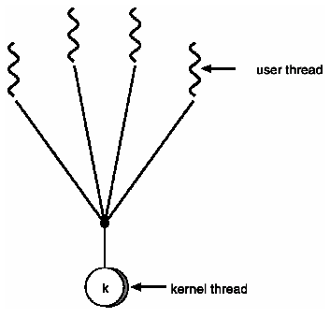
One-to-One
- Each user-level thread maps to kernel thread.
- Examples
- Windows 95/98/NT/2000
- OS/2
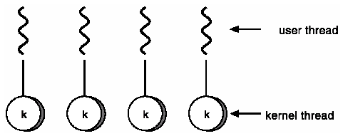
Many-to-Many Model
- Allows many user level threads to be mapped to many kernel threads.
- Allows the operating system to create a sufficient number of kernel threads.
Examples:
- Solaris 2
- Windows NT/2000 with the ThreadFiber package
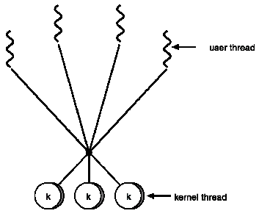

Unit II
Chapter 6
- State and explain the various characteristics criteria for CPU scheduling algorithm.
Scheduling Criteria
- CPU utilization – keep the CPU as busy as possible. In a real system. it should range from 40 percent (for a lightly loaded system) to 90 percent (for a heavily used system).
- Throughput – number of processes that complete their execution per time unit
- Turnaround time – amount of time to execute a particular process
- Waiting time – amount of time a process has been waiting in the ready queue
- Response time – amount of time it takes from when a request was submitted until the first response is produced, not output (for time-sharing environment)
Optimization Criteria
- Max CPU utilization
- Max throughput
- Min turnaround time
- Min waiting time
- Min response time

- Explain the round robin scheduling algorithm. Calculate the average waiting time for the following process using round robin policy with a time slice of 10
Process Burst time
P1 10
P2 29
P3 03
P4 07
P5 12

Chapter 7
- what are the three requirements necessary ot the solution of a critical section problem.
Solution to Critical-Section Problem
- Mutual Exclusion. If process Pi is executing in its critical section, then no other processes can be executing in their critical sections.
- Progress. If no process is executing in its critical section and there exist some processes that wish to enter their critical section, then the selection of the processes that will enter the critical section next cannot be postponed indefinitely.
- Bounded Waiting. A bound must exist on the number of times that other processes are allowed to enter their critical sections after a process has made a request to enter its critical section and before that request is granted.
- Assume that each process executes at a nonzero speed
No assumption concerning relative speed of the n processes.
- explain the term starvation
Starvation – indefinite blocking. A process may never be removed from the semaphore queue in which it is suspended

- Give first attempt for mutual exclusion that leads to Deekker’s Algorithm. State two problems that it encounters and explain how Dekker’s Algorithm overcomes it.
First attempt
Any attempt at mutual exclusion must relay on fundamental exclusion mechanism in the hardware. The most common of these is the constraint that only one access to a memory location can be made at a time. Using this constraint, we reserve a global memory location labeled turn. A process wishing to execute its critical section first examines the contents of turn. If the value of turn is equal to the number of the process, then process may proceed to its critical section, otherwise, it is forced to wait. Our waiting process repeatedly reads the value of turn until it is allowed to enter its critical section. This procedure is known as busy waiting because the thwarted process can do nothing productive until it gets permission to enter its critical section. Instead, it must linger and periodically check the variable; thus it consumes processor time (busy) while waiting for its chance.
After a process has gained access to its critical section and after it has completed the section, it must update the value of turn to that of the other process.
In formal terms, there is a shared global variable:
int turn=0;
This solution guarantees the mutual exclusion property but has two draw backs.
- Process must strictly alternate in their use of their ciritcal section; thus the pace of execution is dictated by slower of the two processes. If a process uses its critical section only once per hour and the next process like to use its critical section 1000 times per hour, the second process is forced to adapt the pace of the first process.
- A much more serious problem is that if one process fails, the other process is permanently blocked. This is true whether the process fails in its critical section or outside it.
Dekker’s Algorithm:
The first known correct software solution to the critical-section problem for two processes was developed by Dekker. The two processes , P₀ and P₁, share the following variables:

boolean flag [2]; /* initially false */
int turn;

Dekker’s algorithm):
do {
flag [i]:= true;

while (flag [j])
if( turn == j)
{flag[i]=false;
while(turn==j);//do nothing
}
critical section
flag [i] = false;
turn=j;
remainder section
} while (1);
Peterson has given more elegant algorithm
do {
flag [i]:= true;
turn = j;
while (flag [j] and turn = j) ;
critical section
flag [i] = false;
remainder section
} while (1);
- Meets all three requirements; solves the critical-section problem for two processes.

The processes share two variables:

boolean flag [2];
int turn;
Initially flag [0] = flag [1] = false, and the value of turn is immaterial (but is either 0 or 1).
To enter the critical section, process Pi first sets flag [i.] to be true and then sets turn to the value j, thereby asserting that if the other process wishes to enter the critical section it can do so. If both processes try to enter at the same time, turn will be set to both i and j at roughly the same tine. Only one of these assignments will last; the other will occur, but will be overwritten immediately. The eventual value of turn decides which of the two processes is allowed to enter its critical section first.
We now prove that this solution is correct. We need to show that:
1. Mutual exclusion is preserved,
2. The progress requirement is satisfied
3. The bounded-waiting requirement is met.

To prove property 1, we note that each Pi enters its critical section only if either flag[j] == false or turn ==j. Also note that, if both processes can be executing in their critical sections at the same time, then flag [0]==flag [11 == true. These two observations imply that P₀ and P₁ could not have successfully executed their while statements at about the same time, since the value of turn can be either 0 or 1, but cannot be both. Hence, one of the processes—say Pj—must have successfully executed the while statement, whereas Pi had to execute at least one additional statement (“turn==j”). However, since, at that time, flag[ j] ==true, and turn ==j, and this condition will persist as long as Pj is in its critical section, the result follows: Mutual exclusion is preserved.
To prove properties 2 and 3, we note that a process Pi can be prevented from entering the critical section only if it is stuck in the while loop with the condition flag[j] == true and turn==j this loop is the only one.
If Pj is not ready to enter the critical section, then flag[ j] == false and Pi can enter its critical section.
If Pj has set flag [j] to true and is also executing in its while statement, then either turn==i or turn ==j + If turn ==i, then P₁ will enter the critical section.
If turn==j then Pj will enter the critical section.
However, once Pj exits its critical section. it will reset flag[j] to false, allowing Pi to enter its critical section.
If Pj, resets flag[j] to true, it must also set turn to i. Thus, since Pi does not change the value of the variable turn while executing the while statement, Pi will enter the critical section (progress) after at most one entry by Pj, (bounded waiting).

- What are monitors? Explain the implementation of mutual exclusion in monitors.
Monitors
- High-level synchronization construct that allows the safe sharing of an abstract data type among concurrent processes.
monitor monitor-name
{
shared variable declarations
procedure body P1 (…) {
. . .
}
procedure body P2 (…) {
. . .
}
procedure body Pn (…) {
. . .
}
{
initialization code
}
}

- To allow a process to wait within the monitor, a condition variable must be declared, as
condition x, y;
- Condition variable can only be used with the operations wait and signal.
- The operation
x.wait();
means that the process invoking this operation is suspended until another process invokes
x.signal();
- The x.signal operation resumes exactly one suspended process. If no process is suspended, then the signal operation has no effect.
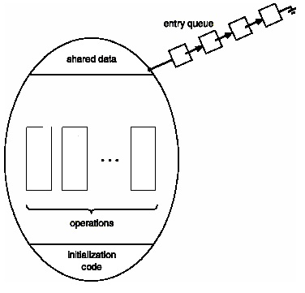

Monitor With Condition Variables
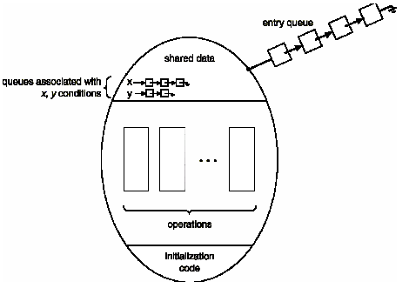

{
enum {thinking, hungry, eating} state[5];
condition self[5];
void pickup(int i) // following slides
void putdown(int i) // following slides
void test(int i) // following slides
void init() {
for (int i = 0; i < 5; i++)
state[i] = thinking;
}
}
void pickup(int i) {
state[i] = hungry;
test(i);
if (state[i] != eating)
self[i].wait();
}

void putdown(int i) {
state[i] = thinking;
// test left and right neighbors
test((i+4) % 5);
test((i+1) % 5);
}
void test(int i) {
if ( (state[(I + 4) % 5] != eating) &&
(state[i] == hungry) &&
(state[(i + 1) % 5] != eating)) {
state[i] = eating;
self[i].signal();
}
}
Monitor Implementation Using Semaphores
- Variables
semaphore mutex; // (initially = 1)
semaphore next; // (initially = 0)
int next-count = 0;
- Each external procedure F will be replaced by
wait(mutex);
…
body of F;
…
if (next-count > 0)
signal(next)
else
signal(mutex);
- Mutual exclusion within a monitor is ensured.
- For each condition variable x, we have:
semaphore x-sem; // (initially = 0)
int x-count = 0;
- The operation x.wait can be implemented as:

x-count++;
if (next-count > 0)
signal(next);
else
signal(mutex);
wait(x-sem);
x-count--;
- Conditional-wait construct: x.wait(c);
- c – integer expression evaluated when the wait operation is executed.
- value of c (a priority number) stored with the name of the process that is suspended.
- when x.signal is executed, process with smallest associated priority number is resumed next.
- Check two conditions to establish correctness of system:
- User processes must always make their calls on the monitor in a correct sequence.
- Must ensure that an uncooperative process does not ignore the mutual-exclusion gateway provided by the monitor, and try to access the shared resource directly, without using the access protocols.
- State the dining philosopher problem and give its solution using semaponre
Dining-Philosophers Problem

Consider five philosophers who spend their lives thinking and eating. The philosophers share a common circular table surrounded by five chairs each belonging to one philosopher. In the center of the table is a bowl of rice, and the table is laid with five single chopsticks. When a philosopher thinks, she does not interact with her colleagues. From time to time, a philosopher gets hungry and tries to pick up the two chopsticks that are closest to her (the chopsticks that are between her and her left and right neighbors). A philosopher may pick up only one chopstick at a time. Obviously, she cannot pick up a chopstick that is already in the hand of a neighbor. When a hungry philosopher has both her chopsticks at the same time, she eats without releasing her chopsticks. When she is finished eating she puts down both of her chopsticks and starts thinking again.
The dining-philosophers problem is considered a classic synchronization problem.
The solution using semaphore is given in the above question.

- Explain the term monitor and explain the advantage of using a monitor over semaphore

With semaphores and event counters, inter-process communication looks easy. t? Forget it. One must be very careful when using semaphores one subtle error and ever thing comes to a grinding halt. It is like programming in assembly language only worse because the errors are race conditions, deadlocks and other forms of unpredictable and irreproducible behaviour.

To make it easier to write correct programs, a higher-level synchronization primitive called a monitor is used.
Monitor
A monitor is a collection of procedures, variables, and data structures that are all grouped together in a special kind of module or package. Processes may call the procedures in a monitor whenever they want to, but they cannot directly access the monitor’s internal data structures from procedures declared outside the monitor.
Monitors have an important property that makes them useful for achieving mutual exclusion: only one process can be active in a monitor at any instant. Typically, when a process call a monitor process is currently active within the monitor. If so, the calling process will be suspended until the other process has left the monitor. If no other process is using the monitor, the calling process may enter.
- write short notes on synchronization in hardware
Synchronization Hardware
- Test and modify the content of a word atomically
.
boolean TestAndSet(boolean &target) {
boolean rv = target;
target = true;

return rv;
}

Mutual Exclusion with Test-and-Set
- Shared data:
boolean lock = false;
- Process Pi
do {
while (TestAndSet(lock)) ;
critical section
lock = false;
remainder section
}

- Atomically swap two variables.
void Swap(boolean &a, boolean &b) {
boolean temp = a;
a = b;
b = temp;
}

Mutual Exclusion with Swap
Shared data (initialized to false):
boolean lock;
boolean waiting[n];
- Process Pi
do {
key = true;
while (key == true)
Swap(lock,key);
critical section
lock = false;
remainder section
}
- Explain the structure of a semaphore highlighting how it can be used for process synchronization.
- Define a semaphore as a record
typedef struct {
int value;
struct process *L;
} semaphore;
- Assume two simple operations:
- block suspends the process that invokes it.
- wakeup(P) resumes the execution of a blocked process P.
- Semaphore operations now defined as
wait(S):
S.value--;
if (S.value < 0) {
add this process to S.L;
block;
}
signal(S):
S.value++;
if (S.value <= 0) {
remove a process P from S.L;
wakeup(P);
}
Semaphore as a General Synchronization Tool
- Execute B in Pj only after A executed in Pi
- Use semaphore flag initialized to 0
- Code:
Pi Pj
M M
A wait(flag)
signal(flag) B
Two Types of Semaphores
- Counting semaphore – integer value can range over an unrestricted domain.
- Binary semaphore – integer value can range only between 0 and 1; can be simpler to implement.
- Can implement a counting semaphore S as a binary semaphore.

- Define the following terms: Semaphore, Monitors. Explain the important features of a monitor that are lacking I semaphore.
Semaphore
To solve the critical section problem a synchronization tool called semaphore can be used. A semaphore S is an integer variable that, apart from initialization, is accessed only through two standard atomic operations: wait and signal.
Monitors:
A high-level abstraction that provides a convenient and effective mechanism for process synchronization. A monitor is characterized by a set of programmer-defined operators. The representation of a monitor type consists of declaration of variables whose values define the state of an instance of the type, as well as the bodies of procedures or functions that implement operations on the type
(Balance see above)

Chapter 8
- Explain how dead lock occurs in reusable and consumable resources
Deadlock can arise if four conditions hold simultaneously
- Mutual exclusion: only one process at a time can use a resource.
- Hold and wait: a process holding at least one resource is waiting to acquire additional resources held by other processes.
- No preemption: a resource can be released only voluntarily by the process holding it, after that process has completed its task.
- Circular wait: there exists a set {P0, P1, …, P0} of waiting processes such that P0 is waiting for a resource that is held by P1, P1 is waiting for a resource that is held by P2, …, Pn–1 is waiting for a resource that is held by
Pn, and P0 is waiting for a resource that is held by P0.

- Explain Deadlock prevention.
Restrain the ways request can be made.
- Mutual Exclusion – not required for sharable resources; must hold for nonsharable resources.
- Hold and Wait – must guarantee that whenever a process requests a resource, it does not hold any other resources.
- Require process to request and be allocated all its resources before it begins execution, or allow process to request resources only when the process has none.
- Low resource utilization; starvation possible.
- No Preemption –
- If a process that is holding some resources requests another resource that cannot be immediately allocated to it, then all resources currently being held are released.
- Preempted resources are added to the list of resources for which the process is waiting.
- Process will be restarted only when it can regain its old resources, as well as the new ones that it is requesting.
- Circular Wait – impose a total ordering of all resource types, and require that each process requests resources in an increasing order of enumeration.

- What do you understand by safe and unsafe state? Explain bankers algorithm with necessary data structure for deadlock avoidance.

- If a system is in safe state ⇒ no deadlocks.
- If a system is in unsafe state ⇒ possibility of deadlock.
- Avoidance ⇒ ensure that a system will never enter an unsafe state.
Banker’s Algorithm
- Multiple instances.
- Each process must a priori claim maximum use.
- When a process requests a resource it may have to wait.
- When a process gets all its resources it must return them in a finite amount of time.
Data Structures for the Banker’s Algorithm
Let n = number of processes, and m = number of resources types.
- Available: Vector of length m. If available [j] = k, there are k instances of resource type Rj available.
- Max: n x m matrix. If Max [i,j] = k, then process Pi may request at most k instances of resource type Rj.
- Allocation: n x m matrix. If Allocation[i,j] = k then Pi is currently allocated k instances of Rj.
- Need: n x m matrix. If Need[i,j] = k, then Pi may need k more instances of Rj to complete its task.
Need [i,j] = Max[i,j] – Allocation [i,j].
Safety Algorithm
- Let Work and Finish be vectors of length m and n, respectively. Initialize:
Work = Available
Finish [i] = false for i - 1,3, …, n.
- Find and i such that both:
(a) Finish [i] = false
(b) Needi ≤ Work
If no such i exists, go to step 4.
- Work = Work + Allocationi
Finish[i] = true
go to step 2.
- If Finish [i] == true for all i, then the system is in a safe state.

Resource-Request Algorithm for Process Pi
Request = request vector for process Pi. If Requesti [j] = k then process Pi wants k instances of resource type Rj.
1. If Requesti ≤ Needi go to step 2. Otherwise, raise error condition, since process has exceeded its maximum claim.
2. If Requesti ≤ Available, go to step 3. Otherwise Pi must wait, since resources are not available.
3. Pretend to allocate requested resources to Pi by modifying the state as follows:
Available = Available = Requesti;
Allocationi = Allocationi + Requesti;
Needi = Needi – Requesti;;
- If safe ⇒ the resources are allocated to Pi.
- If unsafe ⇒ Pi must wait, and the old resource-allocation state is restored
Unit III
Chapter 9
- What is logical and physical address space?

Logical vs. Physical Address Space
- The concept of a logical address space that is bound to a separate physical address space is central to proper memory management.
- Logical address – generated by the CPU; also referred to as virtual address.
- Physical address – address seen by the memory unit.
- Logical and physical addresses are the same in compile-time and load-time address-binding schemes; logical (virtual) and physical addresses differ in execution-time address-binding scheme.
- write short note on contiguous allocation of disk space.

Contiguous Allocation
- Main memory usually into two partitions:
- Resident operating system, usually held in low memory with interrupt vector.
- User processes then held in high memory.
- Single-partition allocation
- Relocation-register scheme used to protect user processes from each other, and from changing operating-system code and data.
- Relocation register contains value of smallest physical address; limit register contains range of logical addresses – each logical address must be less than the limit register.
- Multiple-partition allocation
- Hole – block of available memory; holes of various size are scattered throughout memory.
- When a process arrives, it is allocated memory from a hole large enough to accommodate it.
- Operating system maintains information about:
a) allocated partitions b) free partitions (hole)

- What is paging? Explain the basic method used for paging.
- Logical address space of a process can be noncontiguous; process is allocated physical memory whenever the latter is available.
- Divide physical memory into fixed-sized blocks called frames (size is power of 2, between 512 bytes and 8192 bytes).
- Divide logical memory into blocks of same size called pages.
- Keep track of all free frames.
- To run a program of size n pages, need to find n free frames and load program.
- Set up a page table to translate logical to physical addresses.

- What is segmentation? Explain the basic method used for segmentation

Segmentation
- Memory-management scheme that supports user view of memory.
- A program is a collection of segments. A segment is a logical unit such as:

main program,
procedure,
function,
method,
object,
local variables, global variables,
common block,
stack,
symbol table, arrays

Basic Method
Do users think of memory as a linear array of bytes, some containing instructions and others containing data? Most people would say no. Rather users prefer to view memory as a collection of variable-sized segments, with no necessary ordering among segments
Consider how you think of a program when you are writing it. You think of it as a main program with a set of subroutines, procedures, functions, or modules. There may also be various data structures: tables, arrays, stacks, variables, and so on. Each of these modules or data elements is referred to by name. You talk about “the symbol table,” “function Sqrt”, “the main program₁” without caring what addresses in memory these elements occupy. You are not concerned with whether the symbol table is stored before or after the Sqrt function. Each of these segments is of variable length; the length is intrinsically defined by the purpose of the segment in the program. Elements within a segment are identified by their offset from the beginning of the segment: The first statement of the program the seventeenth entry in the symbol table, the fifth instruction of the Sqri function, and so on.
Segmentation is a memory-management scheme that supports this user view of memory. A logical-address space is collection of segments. Each segment has a name and a length. The addresses specify both the segment name and the offset within the segment. The user there fore specifies each address by two quantities a segment name and an offset. (Contrast this scheme with the paging scheme₁ in which the user specified only a single address, which was partitioned by the hardware into a page number and an. offset, all invisible to the programmer.)
For simplicity of implementation segments are numbered and are referred to by a segment number, rather than by a segment name. Thus, a logical address consists of a two tuple:
<segment-number, offset>.
Normally, the user program is compiled, and the compiler automatically constructs segments reflecting the input program. A Pascal compiler might create separate segments for the following:

1. the global variables;
2. the procedure call stack, to store parameters and return addresses;
3. the code portion of each procedure or function;
4. the local variables of each procedure and function.
A Fortran compiler might create a separate segment for each common block. Arrays might be assigned separate segments. The loader would take all these segments and assign them segment numbers.
Although the user can now refer to objects in the program by a two-dimensional address, the actual physical memory is still, of course, a one-dimensional sequence of bytes. Thus, we must define an implementation to map two dimensional user-defined addresses into one-dimensional physical addresses. This mapping is affected by a segment table, Each entry of the segment table has a segment base and a segment limit. The segment base contains the starting physical address where the segment resides in memory whereas the segment limits specifies the length of the segment.
Chapter 10
- what is page fault frequency strategy
Page Fault
A page fault if the page is not in memory.
- If there is ever a reference to a page, first reference will trap to OS ⇒ page fault
- OS looks at another table to decide:
- Invalid reference ⇒ abort.
- Just not in memory.
- Get empty frame.
- Swap page into frame.
- Reset tables, validation bit = 1.
- Restart instruction: Least Recently Used
- block move
- auto increment/decrement location

- explain the need for virtual memory
The need for virtual memory arises when a process to be loaded can not fully occupy the physical memory.
- Virtual memory – separation of user logical memory from physical memory.
- Only part of the program needs to be in memory for execution.
- Logical address space can therefore be much larger than physical address space.
- Allows address spaces to be shared by several processes.
- Allows for more efficient process creation.
- Virtual memory can be implemented via:
- Demand paging
- Demand segmentation
- What do you understand by virtual memory? Explain the two characteristics of paging and segmentation, which forms the basis of virtual memory.
Repeat the answer above and what is below

Demand Paging
- Bring a page into memory only when it is needed.
- Less I/O needed
- Less memory needed
- Faster response
- More users
- Page is needed ⇒ reference to it
- invalid reference ⇒ abort
- not-in-memory ⇒ bring to memory

Segmentation
- Memory-management scheme that supports user view of memory.
- A program is a collection of segments. A segment is a logical unit

- explain pre-paging

Prepaging
An obvious property of a pure demand-paging system is the large number of page faults that occur when a process is started, This situation is a result of trying to get the initial locality into memory. The same situation may arise at other times. For instance, when a swapped out process is restarted, all its pages are on the disk and each must be brought in by its own page fault. Prepaging is an attempt to prevent this high level of initial, paging. The strategy is to bring into memory at one time all the pages that will be needed
In a system using the working-set model, for example, we keep with each process a list of the pages in its working set. If we must suspend a process (due to an I/O wait or a lack of free frames), we remember the working set for that process When the process is to be resumed (I/O completion or enough free frames), we automatically bring back into memory its entire working set before restarting the process
Prepaging may be an advantage in some cases. The question is simply whether the cost of using prepaging is less than the cost of servicing the corresponding page faults. It may well be the case that many of the pages brought back into memory by prepaging are not used.

Chapter 11
- For a file management system explain the typical operation supported by it. Also state the three objectives of a file management system.

Operations Performed on Directory
- Search for a file
- Create a file
- Delete a file
- List a directory
- Rename a file
- Traverse the file system
File Operations

- Create
- Write
- Read
- file seek – reposition within file
- Delete
- Truncate
- Open(Fi) – search the directory structure on disk for entry Fi, and move the content of entry to memory
- Close (Fi) – move the content of entry Fi in memory to directory structure on disk

Objectives
- To need the data management needs and requirements of the user, which include storage of data and the ability to perform the aforementioned operations.
- To guarantee, to extend possible, that the data in the file are valid.
- To optimize performance, both from the system point of view in terms of overall throughput and from the user’s point of view in terms of response time.

- write short note on directory structure
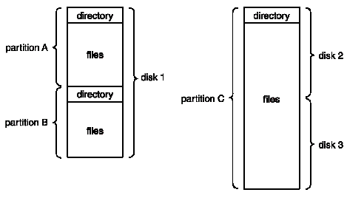
Directory structure
The file systems of computers can be extensive. Some systems store millions of files on terabytes of disk. To manage all these data, we need to organize them. This organization is usually done in two parts. First, disks are split into one or more partitions, also known as minidisks in the IBM world or volumes in the PC and Macintosh arenas. Typically, each disk on a system contains at least one partition, which is a low-level structure in which files and directories reside. Sometimes, partitions are used to provide several separate areas within one disk, each treated as a separate storage device, whereas other systems allow partitions to be larger than a disk to group disks into one logical structure. In this way, the user needs to be concerned with only the logical, directory and file structure, and can ignore completely the problems of physically allocating space for files. For this reason partitions can be thought of as virtual disks. Partitions can also store multiple operating systems, allowing a system to boot and run more than one.
Second, each partition contains information about files within it. This information is kept in entries in a device directory or volume table of contents The device directory (more commonly known simply as a directory) records information-—such as name, location, size, and type— for all files on that partition. Figure shows the typical file-system organization.
The directory can be viewed as a symbol table that translates file names into their directory entries If we take such a view, we see that the directory itself can be organized in many ways. We want to be able to insert entries, to delete entries, to search for a named entry, and to list all the entries in the directory.
- State the different directory structures and explain how tree directory structure is advantageous over other structures.

Single-Level Directory
- A single directory for all users
- Naming problem
- Grouping problem

Two-Level Directory
- Separate directory for each user
- Path name
- Can have the same file name for different user
- Efficient searching
- No grouping capability
Tree-Structured Directories
- Efficient searching
- Grouping Capability
- Current directory (working directory)
- Absolute or relative path name
- Creating a new file is done in current directory
- Delete a file
rm <file-name>
- Creating a new subdirectory is done in current directory
mkdir <dir-name>

Chapter 12
- explain the layered structure of a file system with a suitable diagram

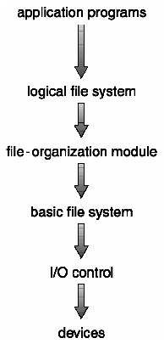

The file system itself is generally composed of many different levels. The structure shown in Figure is an example of a layered design. Each level in the design uses the features of lower levels to create new features for use by higher levels.
The lowest level, the I/O control, consists of device drivers and interrupt handlers to transfer information between the main memory and the disk system. A device driver can be thought of as a translator. Its input consists of high-level commands such as “retrieve block 123”. Its output consists of low level, hardware-specific instructions that are used by the hardware controller, which interfaces the I/O device to the rest of the system. The device driver usually writes specific bit patterns to special locations in the I/O controller’s memory to tell the controller on which device location to act and what actions to take.
The basic file system needs only to issue generic commands to the appropriate device driver to read and write physical blocks on the disk. Each physical block is identified by its numeric disk address (for example, drive 1, cylinder 73, track 2, sector 10).
The file-organization module knows about files and their logical blocks, as well as physical blocks. By knowing the type of file allocation used and the location of the file, the file-organization module can translate logical block addresses to physical block addresses for the basic file system to transfer. Each files logical blocks are numbered from 0 (or 1) through N, whereas the physical blocks containing the data usually do not match the logical numbers, so a translation is needed to locate each block. The file-organization module also includes the free-space manager, which tracks unallocated blocks and provides these blocks to the file-organization module when requested.
Finally, the logical file system manages metadata information. Metadata includes all of the file-system structure, excluding the actual data (or con tents of the files). Thu logical file system manages the directory structure to provide the file-organization module with the information the latter needs, given a symbolic file name. It maintains file structure via file control blocks. A file control block (FCB) contains information about the file, including ownership, permissions, and location of the file contents. The logical file system is also responsible for protection and security.
Many implemented file systems currently exist. Most operating systems support more than one file system. For example, most CD-ROMs are written in the High Sierra format, which is a standard format, agreed upon by CD-ROM manufacturers. Without such a standard, there would be little or no interoperability between systems trying to use CD-ROMs. Aside from removable media file systems, each operating system has one (or more) disk-based file system. UNIX uses the UNIX file system (UPS) as a base. Windows NT supports disk file-system formats of FAT, FAfl2 and NTFS (or Windows NT File System), as well as CD-ROM, DVD, and floppy-disk file-system formats. By using a layered structure for file-system implementation, duplication of code is minimized. The I/O control and sometimes the basic file system code can be used by multiple file systems. Each file system may then have its own logical file system and file-organization modules.

Chapter 13
- Draw a neat labeled diagram and explain the concept of direct memory access.

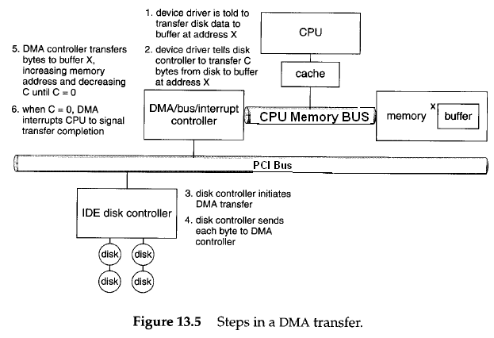
Direct Memory Access(DMA)
For a device that does large transfers, such as a disk drive, it seems wasteful to use an expensive general-purpose processor to watch status bits and to feed data into a controller register 1 byte at a time—a process termed programmed I/O (PlO) Many computers avoid burdening the main Cpu with PlO by offloading some of this work to a special-purpose processor called a direct-memory-access (DMA) controller, To initiate a DMA transfer, the host writes a DMA command block into memory. This block contains a pointer to the source of a transfer, a pointer to the destination of the transfer, and a count of the number of bytes to be transferred. The CPU writes the address of this command block to the DMA controller, and then goes on with other work. The DMA controller proceeds to operate the memory bus directly placing addresses on the bus to perform transfers without the help of the main CPU. A simple DMA controller is a standard component in PCs, and bus-mastering i/o boards for the PC usually contain their own high-speed DMA hardware.
Handshaking between the DMA controller and the device controller is performed via a pair of wires called DMA-request and DMA-acknowledge. The device controller places a signal on the DMA-request wire when a word of data is available for transfer. This signal causes the DMA controller to seize the memory bus, to place the desired address on the memory-address wires, and to place a signal on the DMA-acknowledge wire. When the device controller receives the DMA—acknowledge signal it transfers the word of data to memory, and removes the DMA-request signal.
When the entire transfer is finished, the DMA controller interrupts the CPU.
- explain DMA transfer details
see above answer

Chapter 14

- explain SSTF,SCAN and C-SCAN

SSTF
- Selects the request with the minimum seek time from the current head position.
- SSTF scheduling is a form of SJF scheduling; may cause starvation of some requests.
- Illustration shows total head movement of 236 cylinders.

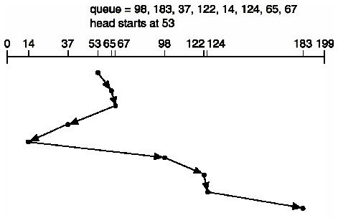

SCAN
- The disk arm starts at one end of the disk, and moves toward the other end, servicing requests until it gets to the other end of the disk, where the head movement is reversed and servicing continues.
- Sometimes called the elevator algorithm.
- Illustration shows total head movement of 208 cylinders.

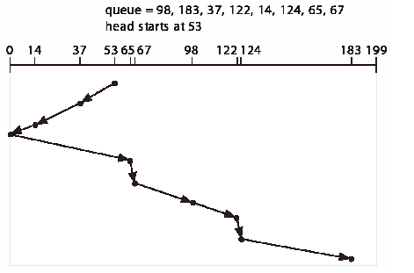
C-SCAN
- Provides a more uniform wait time than SCAN.
- The head moves from one end of the disk to the other. servicing requests as it goes. When it reaches the other end, however, it immediately returns to the beginning of the disk, without servicing any requests on the return trip.
- Treats the cylinders as a circular list that wraps around from the last cylinder to the first one.

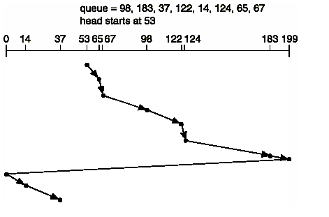

- compare SCAN and C-SCAN policies of disk scheduling. Hence find the average seek time for disk arm movement having a queue in FIFO order: 87, 170, 40, 150, 36, 72, 66, 15 for above two polices. Assume the disk has 300 tracks numbered 0 to 299 and the current position is 60.

Comparison: write the points in the above question
Problem:

a queue in FIFO order: 87, 170, 40, 150, 36, 72, 66, 15
Starting point 60
Scan
Next track accessed no of tracks traversed
40 20
36 4
15 21
0 15
66 66
72 6
87 15
150 63
170 20
Total seek length = 230
Average seek length =230/8=28.75
C-scan
Next track accessed no of tracks traversed
66 6
72 6
87 15
150 63
170 20
299 129
0 299
15 15
36 21
40 4
total seek length =641
average seek length= 641/8=80.125
- A disc drive has 5000 cylinders numbered from 0 to 4999. A drive is currently serving a request at cylinder 143 and the previous request was at 125. the queue of pending request in FIFO order is 86,1470,913, 1774,948, 1509,1022, 1750, 130. Starting from the current head position find the total distance, the disk arm moves to satisfy all the pending requests for FCFS.
Using the method SSTF
Next track accessed no of tracks traversed
86 57
1470 1384
913 557
1774 861
948 826
1509 561
1022 487
1750 728
130 1620
total traverse : 7081

